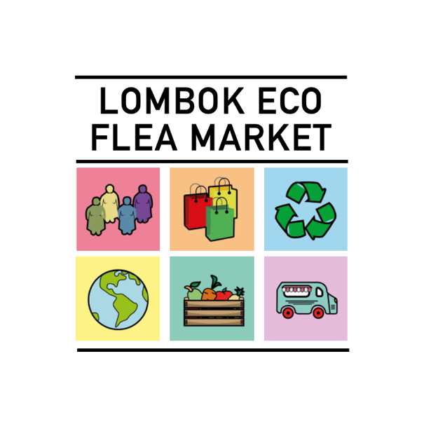
MEMBERSHIP APPLICATION

MEMBERSHIP ADVANTAGES:

MARKETS/EVENTS:
- Cooperation on all LOMBOK ECO FLEA MARKETS in year 2021 with fixed price 50.000 IDR per table
- Advantage in picking your own location in case of limited space
- Minimum 12 eco markets per year, all around Lombok

PROMOTION:
- Promotion on all social platforms of LOMBOK ECO FLEA MARKET (INSTAGRAM, FACEBOOK) exposing your products, dicounts, etc.
- Presence on webpage www.lombokecofleamarket.com with logo and representative photos + contacts
- Promotion in media – article in MY LOMBOK about your brand (2 pages)
DISCOUNTS:
- Discounts with suppliers of eco products to help you with eco packiging (List with contacts will be available on Google Drive and will be regulary updated)
- Discounts with media for promotion activites
CERTIFICATION:
- All members will get a special badge of certificationfor being an eco brand, certified by LOMBOK ECO FLEA MARKET and government
WEBINARS/EDUCATION:
- 4 webinars per year with subjects helping you grow and develop toward more sustinable and eco brand
- Photo session organized for your products (white background) for easier promotional activites
- Free consulting for marketing activites

MEMBERSHIP CRITERIA:
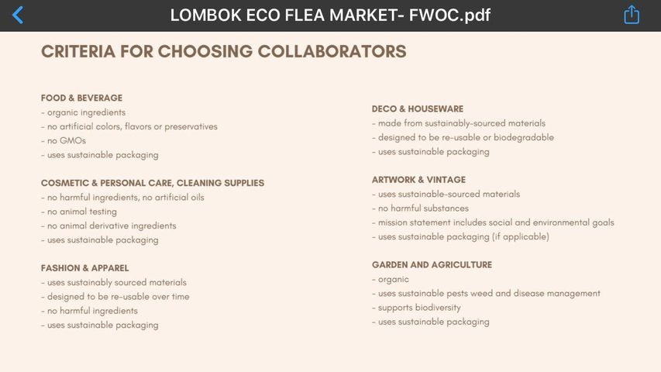

Please list three (3) criteria for which your product qualifies? (List below)
- Criteria 1:
- Criteria 2:
- Criteria 3:

YOUR INFORMATION:
Name of Company/Brand:
Address:
Contact Name:
Email:
Phone Number / WA:
Website Address:
Instagram:
Facebook:
Other:

YOUR IMAGES:
Please send us your logo, description of your company and six (6) representative photos of your products on 081 338 424 605 What’s App

ANNUAL MEMBERSHIP FEE:
Membership for year 2021 is 350.000,00 IDR

TRANSFER INFORMATION:
BENEFICARY NAME: Panca Adi Saputra (UD LOMBOK ECO MARKET)
BANK NAME: PT CIMB Niaga, MATARAM
REK. NU: 762438536000

